**Shop Database System**

**.**

**Content**

* **Introduction**
* **Entity & Attributes into ER diagram**
* **ER Diagram**
* **Schema mapping**
* **Relational Schema**
* **Pictures of the SQL Database**

**Introduction**

The database system design to DSI, PVT.LTD Shoe Company. It contain information about sellers, buyers, products, payments, orders and customers. It define way of maintain the business details.

**Entity & Attributes into ER diagram**

# **Customer_details**

* **Cus_id – Primary key**
* **Cus_name**
* **Cus_email**
* **Cus _mobile – multivalued attribute**
* **Buyer_id**
* **Cus_password**
* **Order_id**

**Buyer**

* **Buyer_id – Primary key**
* **Buyer_name**
* **Login_type**
* **S_id**
* **Pro_id**
* **Role_id**

**Seller**

* **S_id – Primary key**
* **S_name**
* **S_email**
* **S_type**
* **S_mobile – multivalued attribute**
* **City**
* **Shop_id**

**Shop**

* **Shop_id – Primary key**
* **Shop_name**
* **Shop_type**
* **City**

**Order_details**

* **Order_id – Primary key**
* **Order_type**
* **Order_date**

**Payment**

* **Pay_id – Primary key**
* **Pay_amount**
* **Pay_type**
* **Pay_date**
* **Order_id**

**Role**

* **Role_id – Primary key**
* **Role_name**

**Product**

* **Pro_id – Primary key**
* **Pro_cus_id**
* **Pro_type**
* **Pro_item**
* **Pro_desc**
* **quantity**

**ER Diagram**

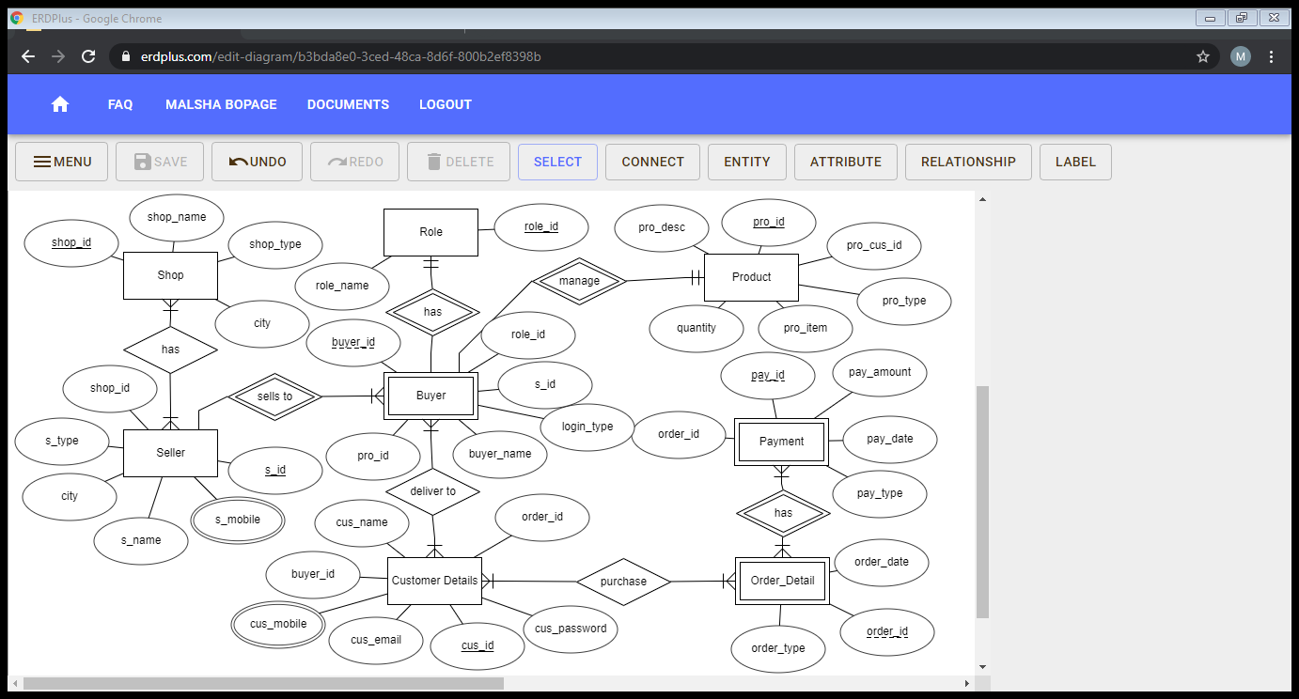

**Schema mapping**

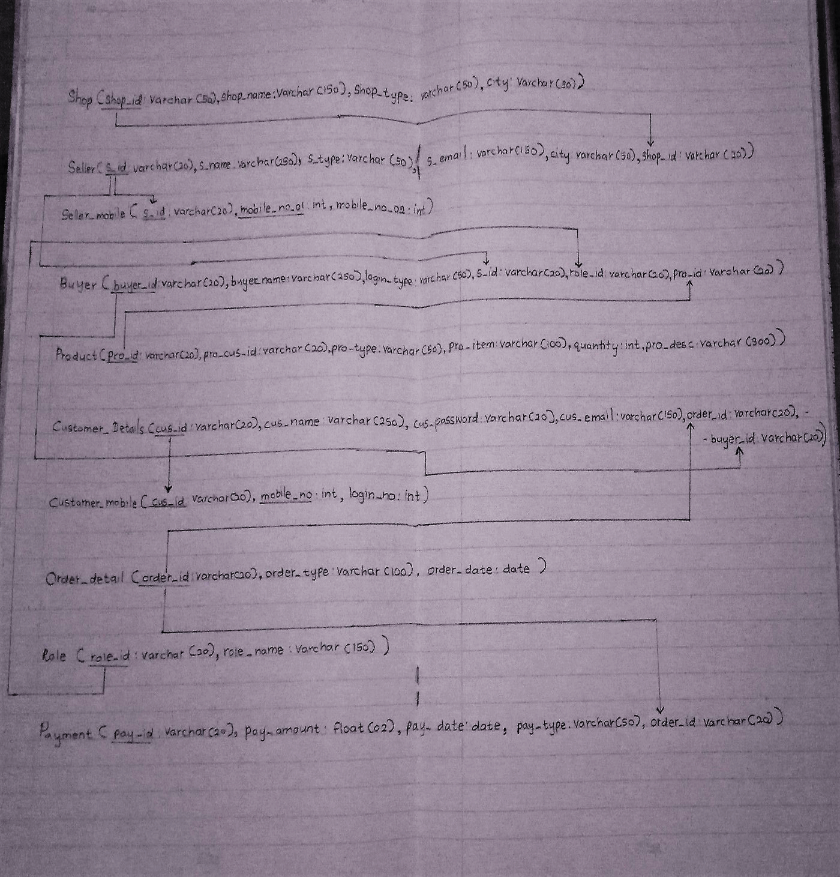

**Relational Schema**

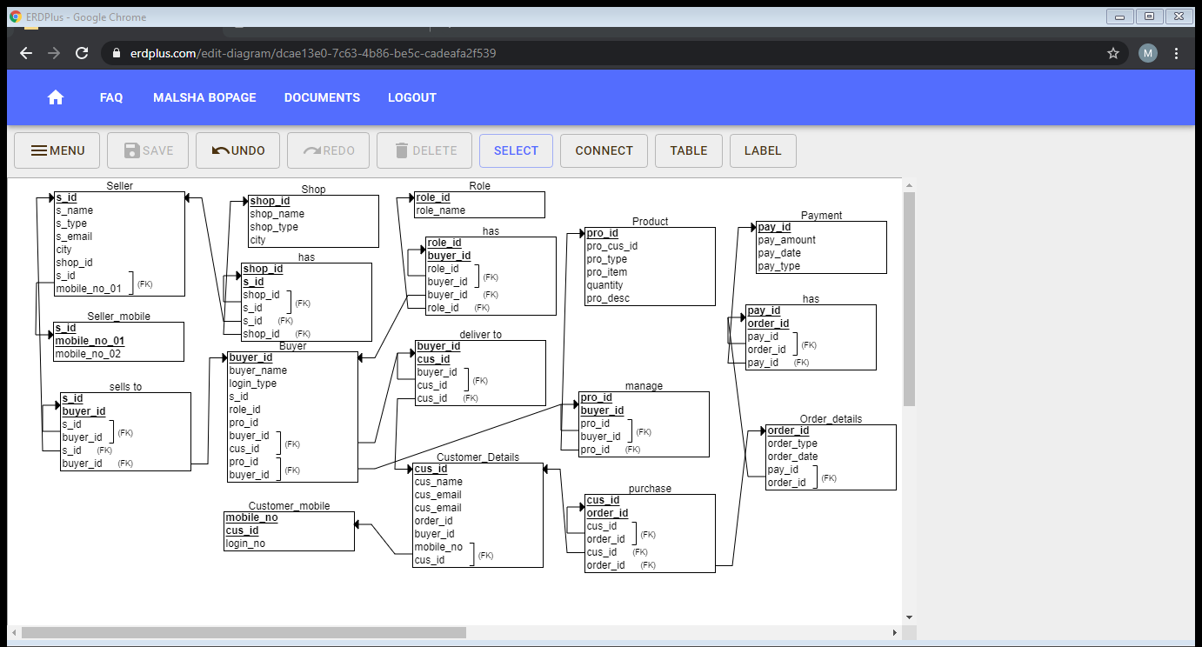

**Pictures of the SQL Database**

SELECT Queries

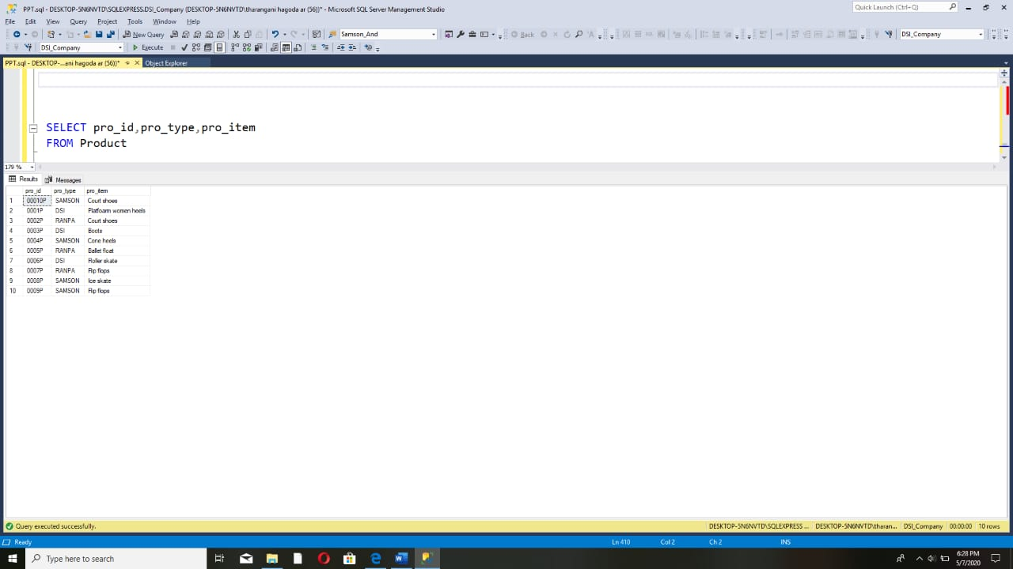

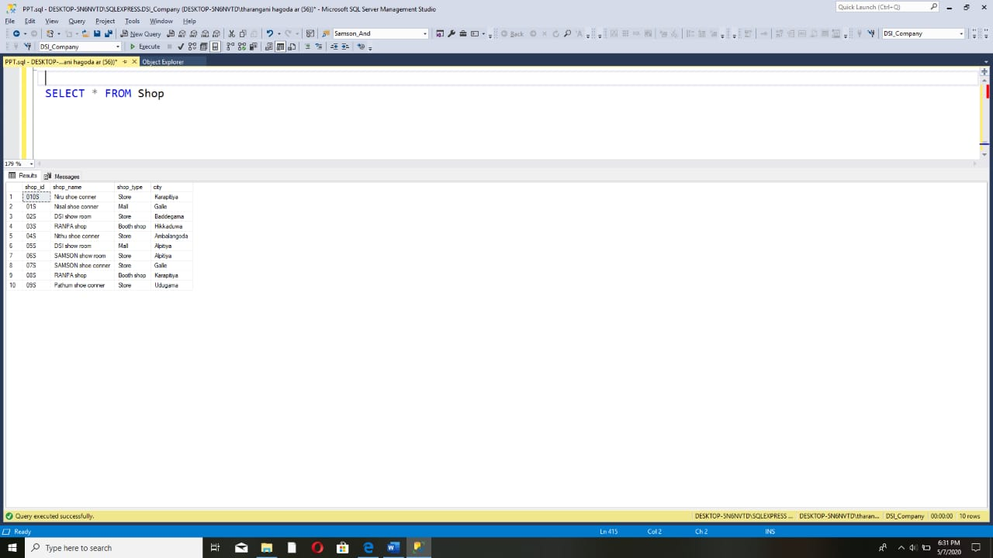

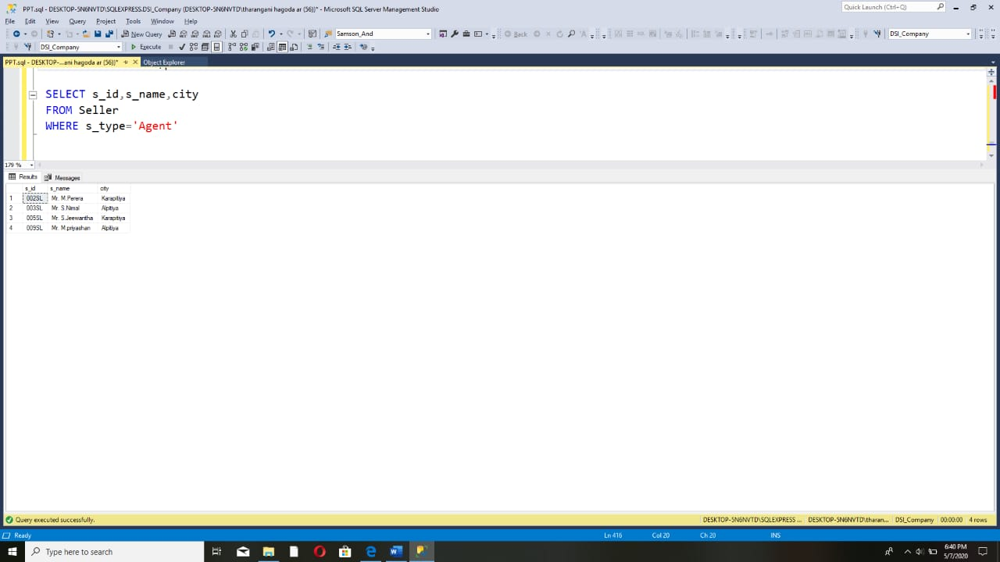

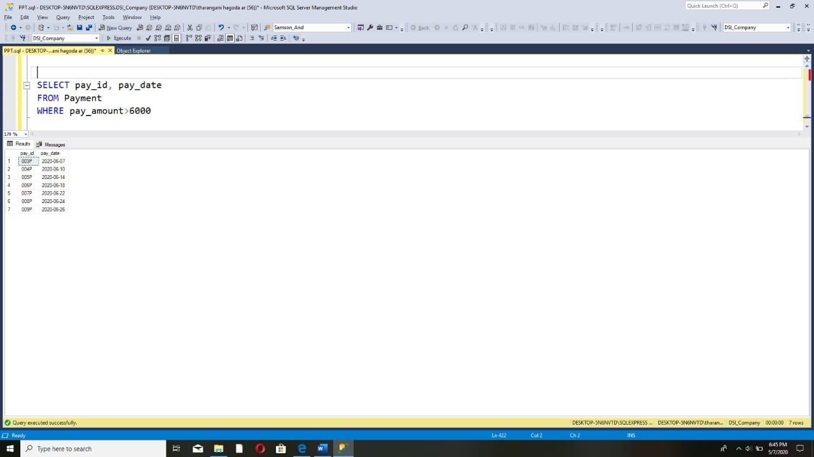

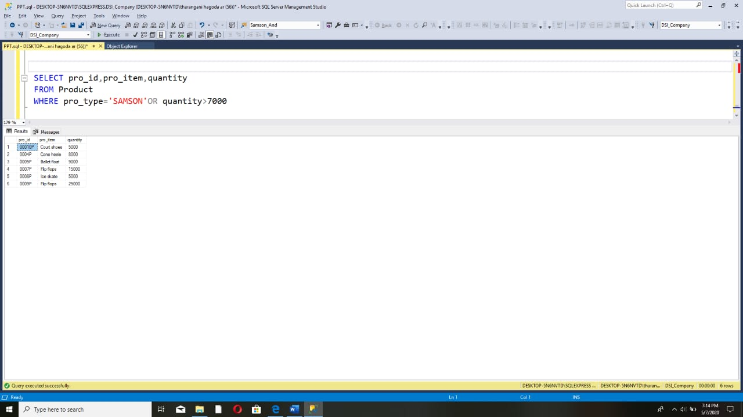

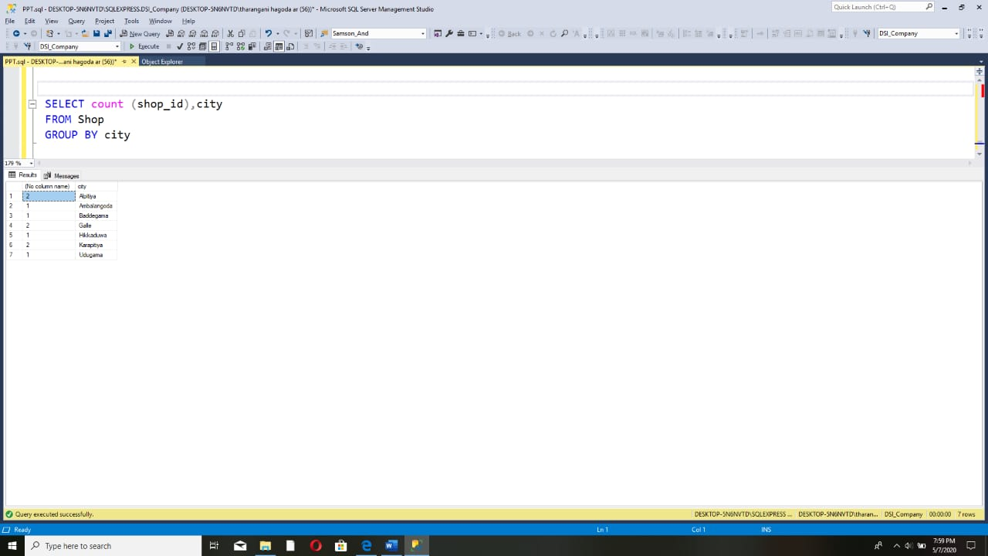

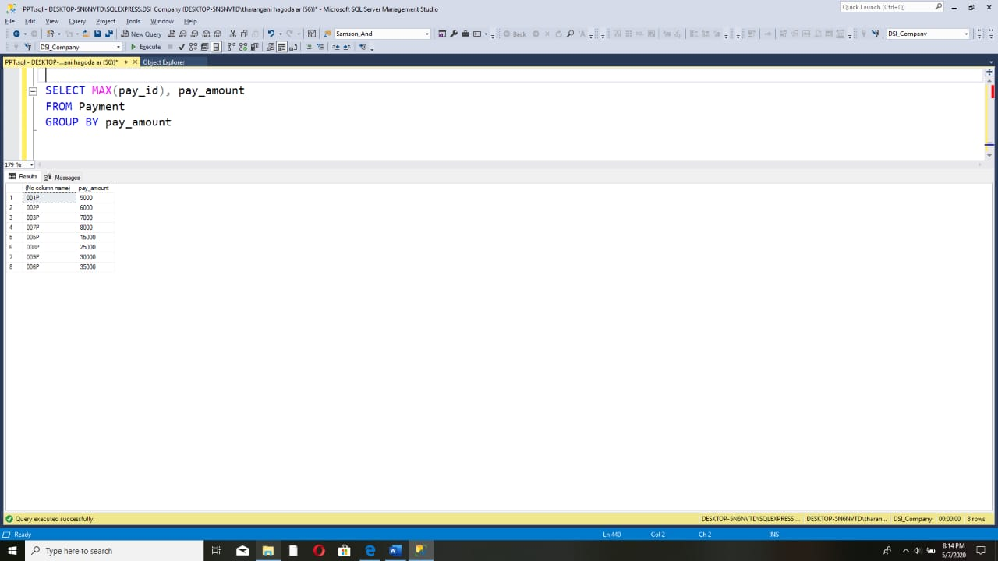

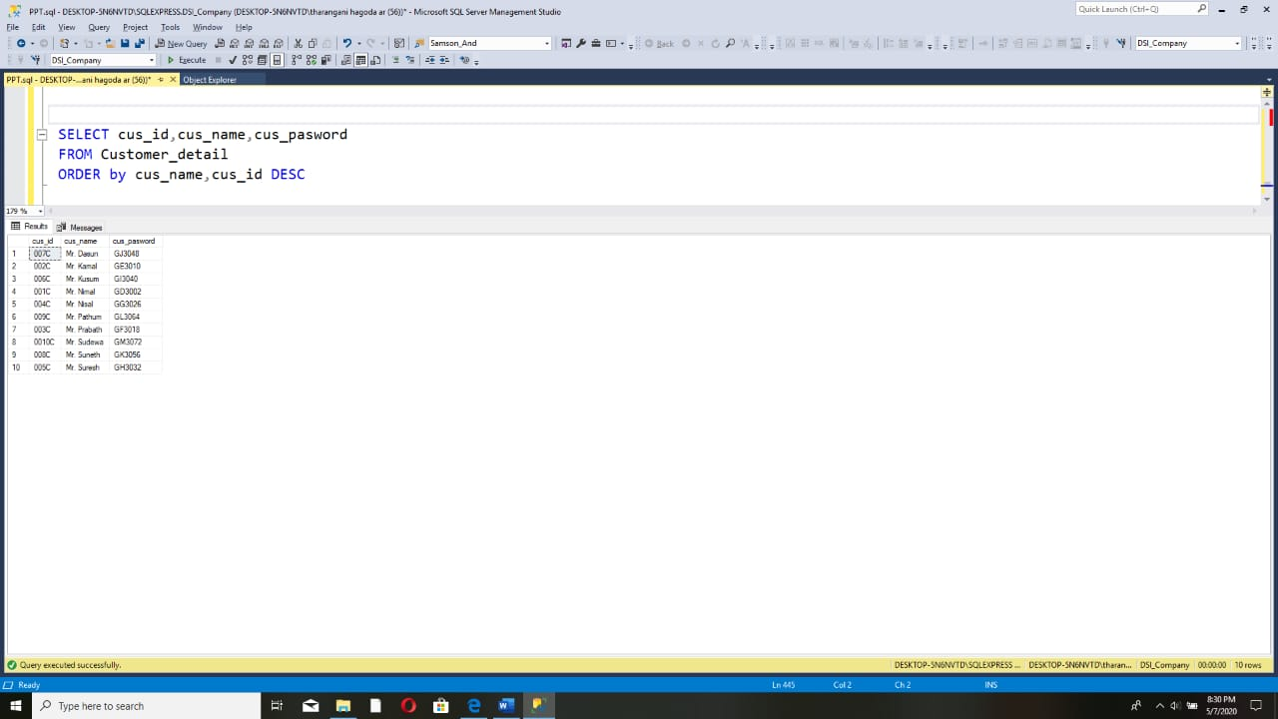

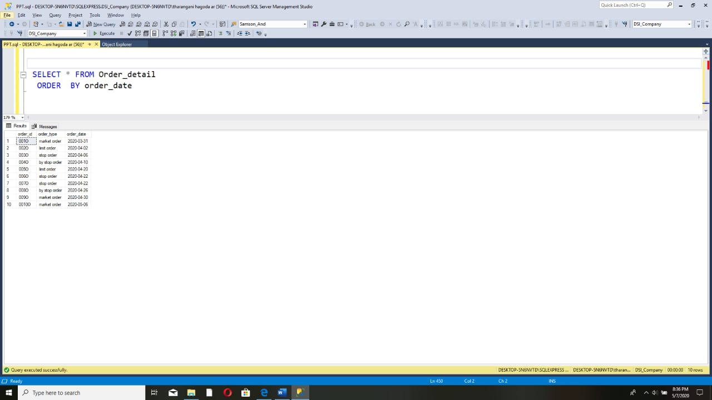

JOINS

